Game Design Document

Fill up the following document

1. Write the title of your project.

Galaga

1. What is the goal of the game?

To Shoot other spaceships while they are coming towards you and don’t let them touch you

1. Write a brief story of your game.

There is overpopulation on earth so a 100 people are on a ship to find a new land. The captins was eating a sandwich that he droped on the shoot button and accedinly hit an alien home. So now the aleins are trying to takedown the ship.

1. Which are the playing characters of this game?

* Playing characters are the ones who respond to the user based on the input from the user.
* Cars, monkeys, dinos, wizards, etc., are the playing characters in the game.

|  |  |  |
| --- | --- | --- |
| Number | Character Name | What can this character do? |
| 1 | Earth Spaceship | Fight off the aliens |
| 2 |  |  |
| 3 |  |  |
| 4 |  |  |
| 5 |  |  |
| 6 |  |  |
| 7 |  |  |
| 8 |  |  |

1. Which are the Non-Playing Characters of this game?

* Non-Playing characters are the ones that don't have an action or behavior when the user interacts with the game.
* Hurdles, stones, bananas, coins, etc., are non-playing characters in the game.

|  |  |  |
| --- | --- | --- |
| Number | Character Name | What can this character do? |
| 1 | Alien ship 1 | Cant shoot only trying to move and hit you |
| 2 | Alien ship 2 | Cannot move but trying to shoot you |
| 3 |  |  |
| 4 |  |  |
| 5 |  |  |
| 6 |  |  |
| 7 |  |  |
| 8 |  |  |

Draw your imagination of this game. What does this game look like?

* Draw the game either on your computer or on paper.
* Add images of the game scenes to show each of the playing and non-playing characters at least once.
* 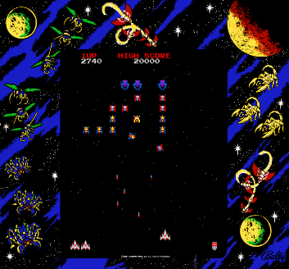

How do you plan to make your game engaging?

I will make it challenging and add sounds and different colors and pictures to make this game engaging